Activity 2: Creation of New Update Set
Objective
An Update Set records all the configuration changes made in ServiceNow (table, fields, dependency and flow) so that the whole project can be tracked and moved to another instance. A new Local Update Set named Project Update Set is created and made current before starting any development work.
Navigation Steps
- Go to All menu and search for Update Set.
- Under System Update Sets, select Local Update Sets.
- Click the New button on the top right corner of the page.
- Name: Project Update Set.
- State: In progress.
- Application: Global.
- Click Save to save the form.
- Under Related Links, click Make This My Current Set.
- The created Update Set now appears as the Current update set.
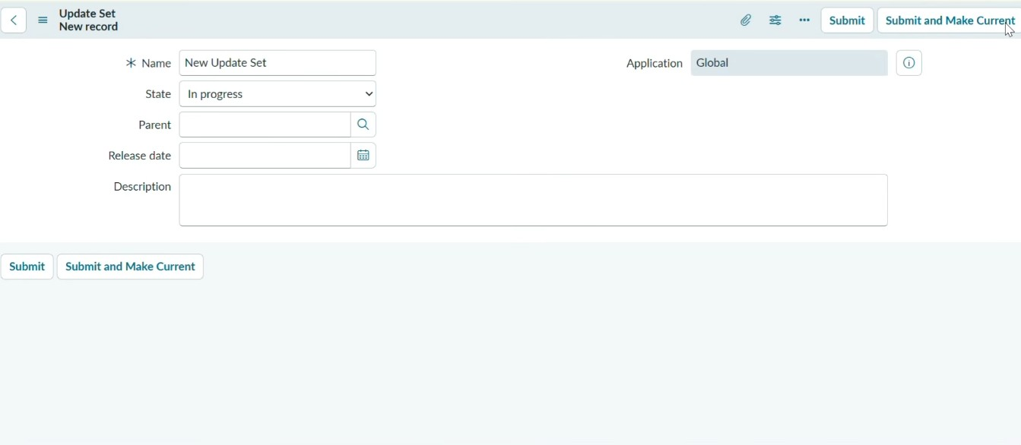
Screenshots
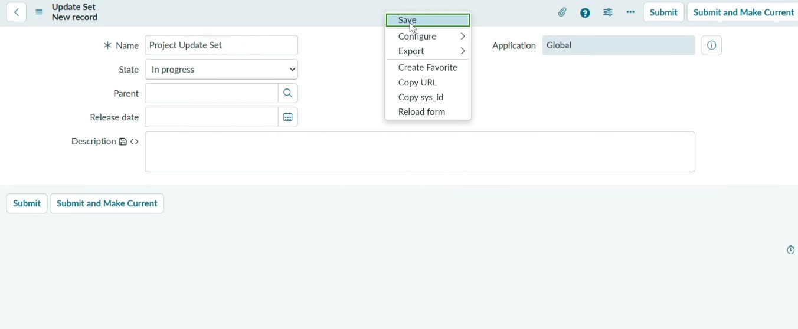

Result
The Update Set "Project Update Set" was created in the Global application with the state In progress and set as the current update set. All further changes in the project are now captured in it.

